
Final Project
Course Project
Sachin Srinivasan
Bench # 3
Circuit Theory II
Section 804
Course number (EECE.2080)
Date submitted 5/1/2026
Due date 5/1/2026

I: Equipment
Table 1: Equipment Used
Equipment Type | Details
DMM Bench Top | Make: Keithley  Model: 2110 5 ½  Serial #: 8007796
DMM Hand Held | Make: Tenma  Model: 72-9385  SPC Type #: DB0E48
Dual Power Supply | Make: GWINSTEK  Model: GPD-3303D  Serial #: EL832106
Oscilloscope | Make: Keysight  Model: InfinityVision 2000 X-Series  Serial #: CN63261485
Function Generator | Make: Tektronix  Model: AFG1022  Serial #: AFG10221537036
Analog Discovery Kit 2 | Make: Digilent  Model: ADK2  Serial #: DB0E48
- Bench Shoebox  - Breadboard  - RBOX-408 Resistance Decade Box or equivalent | N/A

Table 2: Components Used
Components | Quantity
10k Ω resistors | 1
24-gauge wire (various colors) | As needed

II: Introduction
This project was intended to design and construct a circuit that can analyze the values of the components of an unknown series RC circuit by utilizing the Analog Discovery Kit (ADK) and MATLAB software. This circuit should be able to receive an unknown two-terminal series RC circuit composed of one resistor and one capacitor, provide an AC signal, measure their voltages, and determine the values of the resistance and capacitance of each component based on one exported CSV data. The specific values that must be measured in the project are in the range of 10 kΩ to 50 kΩ for resistors and 1 nF to 100 nF for capacitors.
This was done by placing a resistor, whose value was known to us, in series with the unknown network as a sensing resistor. A sinusoidal input voltage was provided to the network using an ADK function generator. Two channels of an ADK oscilloscope were used to measure the input voltage and the voltage at the terminals of the resistor in series with the unknown network. This data was then exported into a CSV file and further analyzed in MATLAB. In this way, a MATLAB script calculated the current flowing through the network, determined the impedance of the unknown network, and found the resistance and capacitance of the unknown load.
This assignment is a good example of applying sinusoidal steady-state analysis techniques and calculating impedances in the lab environment.

Important Equations:
- 1/jwc
- I = Vs / Rsense
- W = 2πF
- V = IR

IV: Circuit Description
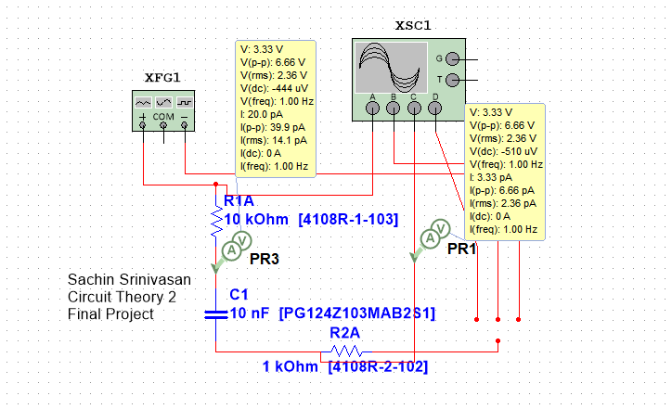
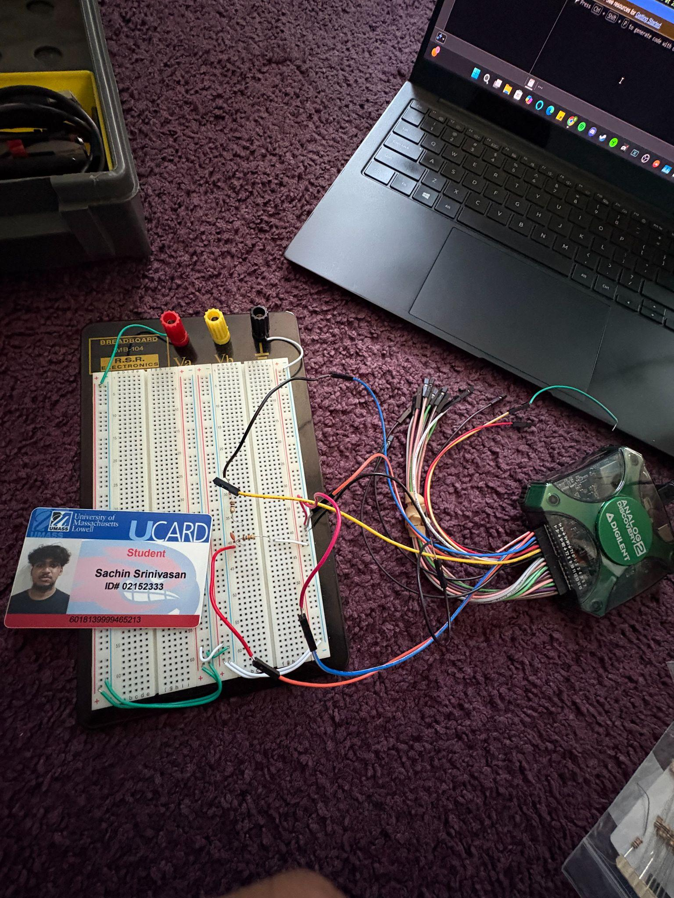
V: Measurement
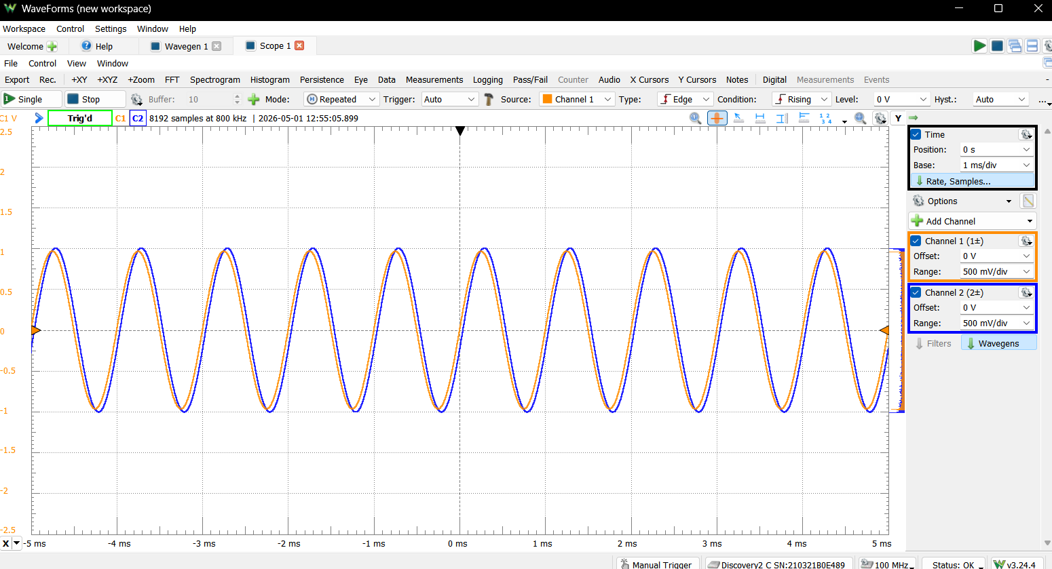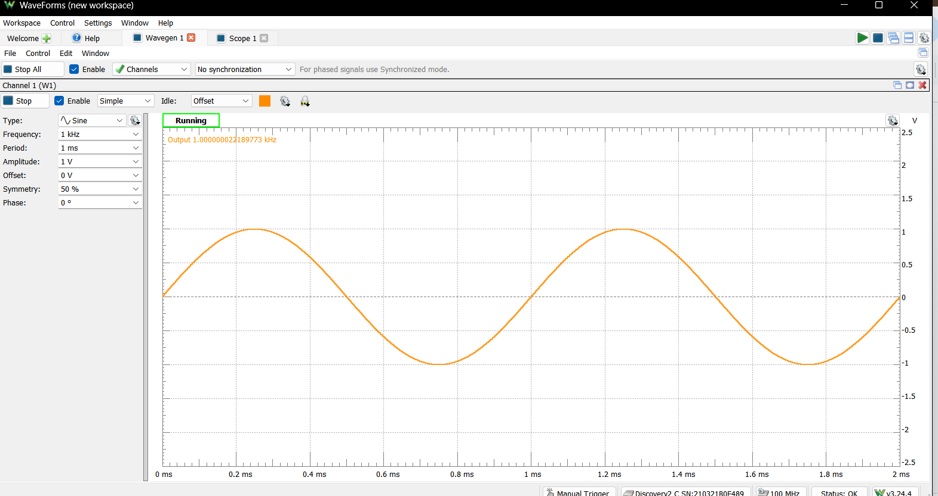
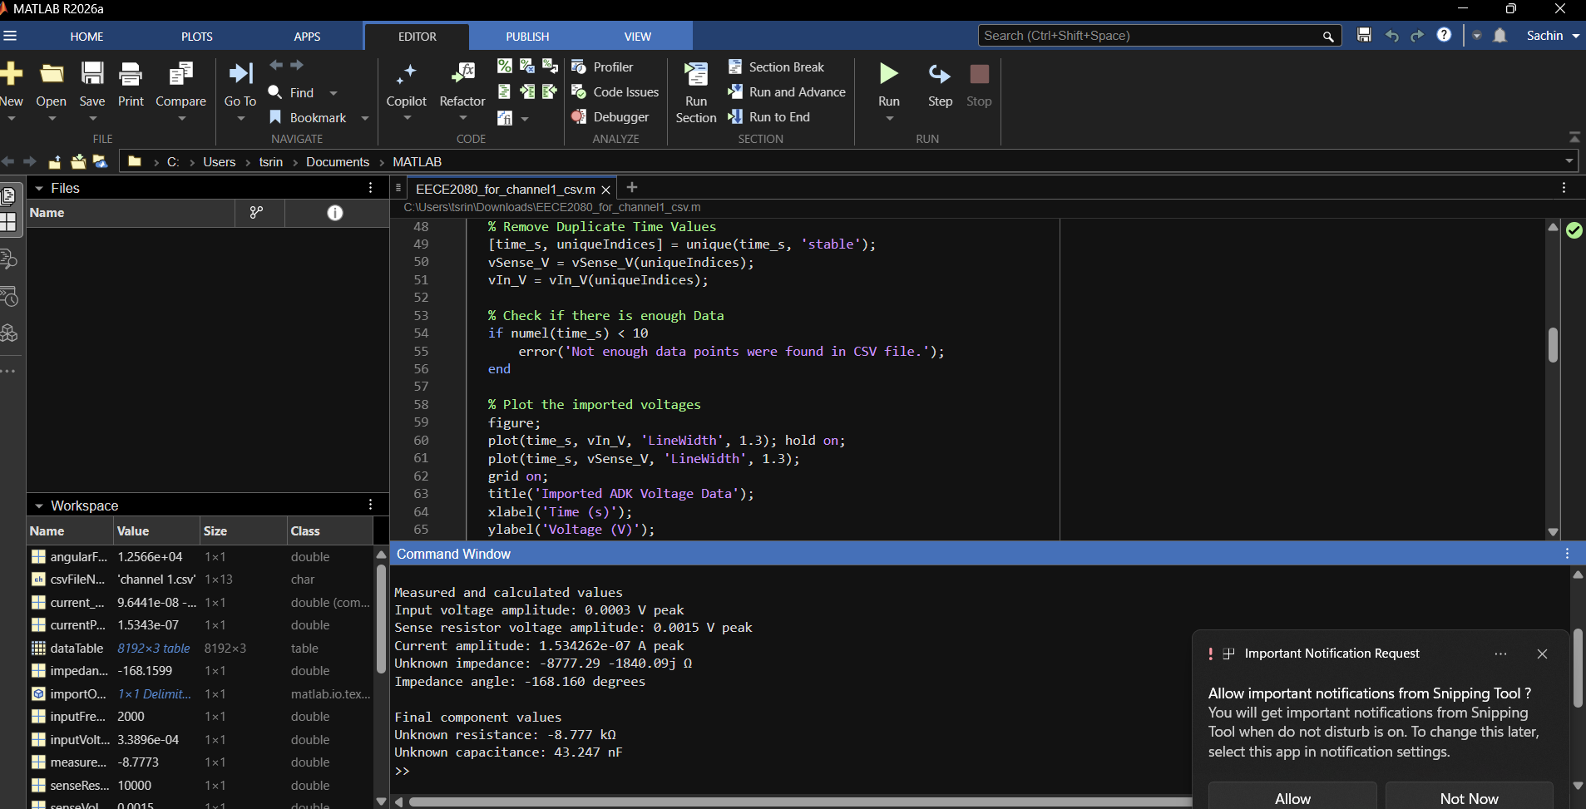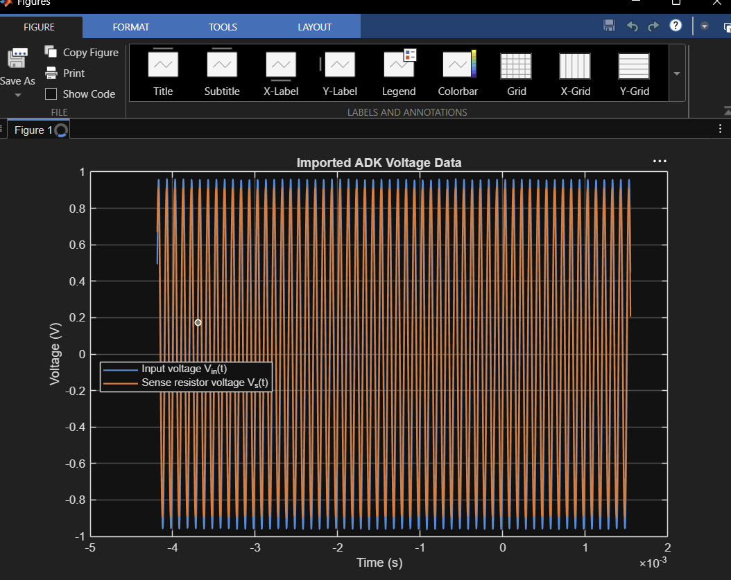
VI: Conclusion
This project was able to successfully implement a procedure for finding the resistance and capacitance of an unknown series RC network through the use of the Analog Discovery Kit (ADK) and MATLAB. With the help of a sinusoidal source voltage, input voltages and the voltage across a known sense resistor were measured and analyzed by importing them into MATLAB for further analysis. Through the principles of AC steady-state circuits, it was then possible to find the values of the unknown resistor and capacitor in the circuit.
Various sources of experimental errors could be seen in this experiment. First, the value of the sense resistor was not exactly what it was supposed to be because of resistor tolerances. Second, the connections on the breadboard and any jumper wires might have contributed some parasitic effects. Third, the measurements of the waveforms depend heavily on choosing the right frequency and making sure that the ADK displays good sine waves before exporting it. Even a bit of noise, poor sampling resolution, or just improper placement of the probe could contribute to the calculation of the amplitude and phase values, which will influence the impedance calculations. Moreover, capacitor tolerances cannot be neglected since they can explain some of the differences between theoretical and observed data.
One of the primary challenges faced in this experiment was designing a setup that would be able to effectively distinguish between the unknown resistor and capacitor using just two voltage readings. There was a need to consider a configuration that minimizes current flow while being simple enough to justify, and yet allows the MATLAB program to calculate the impedance values. One of the major challenges in the experiment was ensuring that the CSV files obtained from the ADK were properly imported into MATLAB because of the possibility of having some header information.
The project also served to teach a number of valuable lessons. The first of these was that practical systems of measurements may be designed based on fundamental circuitry principles, including Ohm’s Law, Kirchhoff’s Voltage Law, and complex impedance. The second lesson concerned the fact that it is not enough to know how to code in MATLAB; one must know why each equation and step is used. The third lesson learned during the project was that practical experiments may sometimes require troubleshooting and frequency adjustment, rather than direct implementation of theoretical models from books.

VII: Appendix (MATLAB Code)
% EECE 2080 Basic EE Lab II - Course Project
% Name: Sachin Srinivasan
% Date: 04-22-2026
%
% Description:
% This script is tailored to the uploaded ADK CSV file named
% "channel 1.csv". It imports the exported data, plots both measured
% voltages versus time on one graph, and calculates the values of an
% unknown series RC network.
%
% Circuit assumption:
% ADK W1 -> unknown series RC -> Node A -> Rsense -> ground
%
% Probe assumption:
% Channel 1 measures Vs across Rsense
% Channel 2 measures Vin at the input node
%
% This version is for the main project only.
% No bonus features are included.
% The frequency is fixed at 2000 Hz.

clear; clc; close all;

csvFileName = 'channel 1.csv';
senseResistor_Ohms = 10000;
inputFrequency_Hz = 2000;
angularFrequency_rad_per_s = 2 * pi * inputFrequency_Hz;

importOptions = detectImportOptions(csvFileName, 'FileType', 'text');
importOptions.CommentStyle = '#';
dataTable = readtable(csvFileName, importOptions);

time_s = dataTable{:,1};
vSense_V = dataTable{:,2};
vIn_V = dataTable{:,3};

time_s = time_s(:);
vSense_V = vSense_V(:);
vIn_V = vIn_V(:);

validRows = ~(isnan(time_s) | isnan(vSense_V) | isnan(vIn_V));
time_s = time_s(validRows);
vSense_V = vSense_V(validRows);
vIn_V = vIn_V(validRows);

[time_s, uniqueIndices] = unique(time_s, 'stable');
vSense_V = vSense_V(uniqueIndices);
vIn_V = vIn_V(uniqueIndices);

if numel(time_s) < 10
error('Not enough numeric data points were found in the CSV file.');
end

figure;
plot(time_s, vIn_V, 'LineWidth', 1.3); hold on;
plot(time_s, vSense_V, 'LineWidth', 1.3);
grid on;
title('Imported ADK Voltage Data');
xlabel('Time (s)');
ylabel('Voltage (V)');
legend('Input voltage V_{in}(t)', 'Sense resistor voltage V_s(t)', 'Location', 'best');

Vin_phasor = fitPhasor(time_s, vIn_V, angularFrequency_rad_per_s);
Vs_phasor = fitPhasor(time_s, vSense_V, angularFrequency_rad_per_s);

current_phasor_A = Vs_phasor / senseResistor_Ohms;
vUnknown_phasor = Vin_phasor - Vs_phasor;
zUnknown_Ohms = vUnknown_phasor / current_phasor_A;

unknownResistance_Ohms = real(zUnknown_Ohms);
unknownReactance_Ohms = imag(zUnknown_Ohms);

if unknownReactance_Ohms >= 0
error(['The reactance was not negative. Check the wiring, ', ...
'the probe placement, and whether the unknown load is a series RC network.']);
end

unknownCapacitance_F = -1 / (angularFrequency_rad_per_s * unknownReactance_Ohms);

inputVoltagePeak_V = abs(Vin_phasor);
senseVoltagePeak_V = abs(Vs_phasor);
currentPeak_A = abs(current_phasor_A);
impedanceAngle_deg = rad2deg(angle(zUnknown_Ohms));

fprintf('EECE 2080 Project Results\n');
fprintf('CSV file used: %s\n', csvFileName);
fprintf('Input frequency: %.3f Hz\n', inputFrequency_Hz);
fprintf('Known sense resistor: %.3f k%c\n', senseResistor_Ohms/1000, 937);

fprintf('\nMeasured and calculated values\n');
fprintf('Input voltage amplitude: %.4f V peak\n', inputVoltagePeak_V);
fprintf('Sense resistor voltage amplitude: %.4f V peak\n', senseVoltagePeak_V);
fprintf('Current amplitude: %.6e A peak\n', currentPeak_A);
fprintf('Unknown impedance: %.2f %+.2fj %c\n', real(zUnknown_Ohms), imag(zUnknown_Ohms), 937);
fprintf('Impedance angle: %.3f degrees\n', impedanceAngle_deg);

fprintf('\nFinal component values\n');
fprintf('Unknown resistance: %.3f k%c\n', unknownResistance_Ohms/1000, 937);
fprintf('Unknown capacitance: %.3f nF\n', unknownCapacitance_F * 1e9);

function phasorValue = fitPhasor(time_s, signal_V, angularFrequency_rad_per_s)
designMatrix = [cos(angularFrequency_rad_per_s * time_s), ...
sin(angularFrequency_rad_per_s * time_s), ...
ones(size(time_s))];

coefficients = designMatrix \ signal_V;

a = coefficients(1);
b = coefficients(2);

phasorValue = a - 1j*b;
end

IX: References
1) Recitation textbook
2) Professor Wakim

